Big Mountain Ski Resort

Context

Big Mountain Resort uses a pricing strategy to charge a premium above the average price of resorts in its market segment, however, this does not reflect the investments made in the facilities for the resort.

TL;DR

A model was made which suggest that tickets be raised to a minimum of $85.40, which will better capitalize on the current facilities and cover the cost of the newly installed chair lift. The model indicates future investments should include increasing the vertical drop by 150 feet and adding the accompanying chair lift for that.

Model

A predictive model was created for ticket price based on a number of facilities, or properties, boasted by resorts (at the resorts). This model will be used to provide guidance for Big Mountain's pricing and future facility investment plans.

Four key features were chosen to model. These features impacted ticket prices the most out of all features with available data. These are listed here in order of impact:

* Fast Quads
* Runs
* Snow-making
* Vertical Drop

Findings

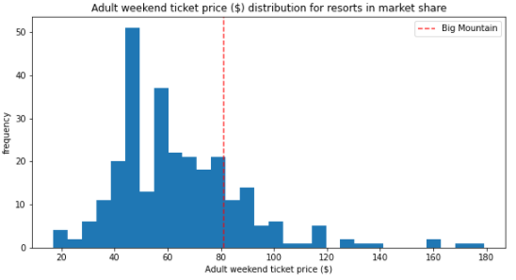

Big Mountain Resort currently charges $81 for tickets.

Big Mountain Resort modelled price is $95.87 with an expected mean absolute error of $10.39, this suggests there is room for an increase.

At minimum, the price of tickets should be raised to $85.40 which would increase the ticket price by $4.40. This provides and additional $1,540,000 which will cover the additional operating cost of the new chair lift.

Potential Scenarios

1. Permanently closing down up to 10 of the least used runs. This doesn't impact any other resort statistics.

Closing down one of the least used runs does not have a direct impact on ticket price, thus it is recommended to proceed as it will reduce operating costs.

1. Increase the vertical drop by adding a run to a point 150 feet lower down but requiring the installation of an additional chair lift to bring skiers back up, without additional snow making coverage

The model supports this as a wise decision for impacting ticket price positively

1. Same as number 2, but adding 2 acres of snow making cover

The model does not indicate that this will impact the ticket price, but may cause may increase operating costs.

1. Increase the longest run by 0.2 mile to boast 3.5 miles length, requiring an additional snow making coverage of 4 acres

The model does not indicate that this will impact the ticket price, but may increase operating costs.

**D**

**H**